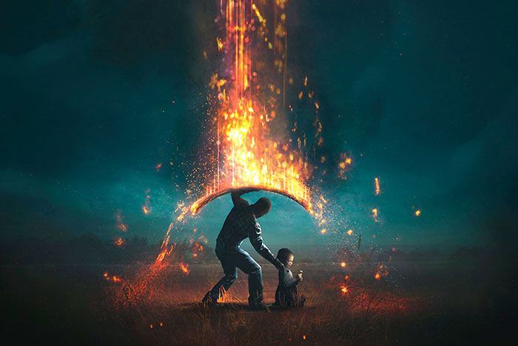
In everything I did, I showed you that by this kind of hard work himself said: ‘It is more blessed to give than to receive.’

We stand against the darkness, We fight against fiery darts from the evil one…
WILL YOU STAND IN THE GAP TO PROTECT THE DEFENSELESS?

Acts 20:35
As believers and disciples of Christ, we can be assured of five things; faith, salvation, eternity, God’s goodness, and Gods promises. We are called to love, because Christ loved. He calls us to walk alongside those with heavy burden and to offer compassion and hope. He feels our pain and he hears our suffering, but be assured that God Never Wastes Pain. We are called to be His light in the darkness, to share His truth when surrounded by lies. He is the ultimate healer and our key to salvation.
Every Life Is Precious
Daily we see and work with girls, women and families experiencing fear, desperation, and trauma. Lies about Her inadequacy in conjunction with the unhealed wounds from trauma give Satan the ultimate weapon against vulnerable women and defenseless babies. Abortion wreaks death, havoc and deeper pain than could have ever been imagined and ripples into the lives of everyone in Her sphere of influence. We are called to stand in the gap. Heart of the Hills Resources is a place of hope; we share truth and empower women to rise up against their fears; and to have faith that they are enough, they are equipped, and they are not alone.

“…no weapon forged against you will prevail…” (Isaiah:54). In the first quarter of 2022 the Center saw 34 client appointments, in contrast, at the close of the first quarter of 2023 we had seen 354 client appointments. The Lord is moving, and these women are looking for reassurance that they have options; that She can choose life when Her circumstance tells Her otherwise. BUT WE NEED YOUR HELP. At this rate, our resources will not be able to serve the dramatic increase in pregnancy help needed in our community. We need to hire staff, cover costs for identified individuals to receive prenatal care assistance, keep our baby boutique

stocked, purchase additional curriculum for our fatherhood program & pregnancy loss / post abortive healing programs.

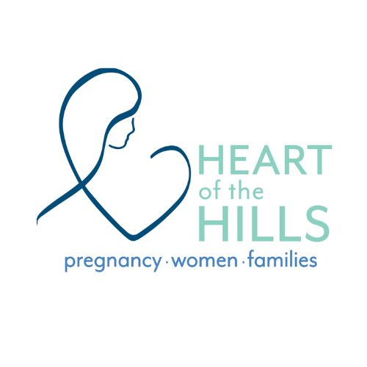
We saw 7 women from our community this past month planning to electively terminate their pregnancy and we were able to surround them with love, acceptance, and God’s truth; this is the space where hearts are changed, this is where “He heals the brokenhearted and binds up their wounds.” (Psalms 147:3) You can help us be here for these women, tomorrow and next month.

Blessings,
Nicole Davis, Executive Director

